Eventmasters Limited
Plumpton Racecourse is elated to announce an exciting partnership with Eventmasters Limited, one of the leading providers of corporate hospitality packages within the UK. Eventmasters has entered into a three-year agreement to sponsor Plumpton Racecourse. The three-year commitment by Eventmasters is a testament to the mutual trust and shared vision between both organisations to provide exceptional racing experiences.
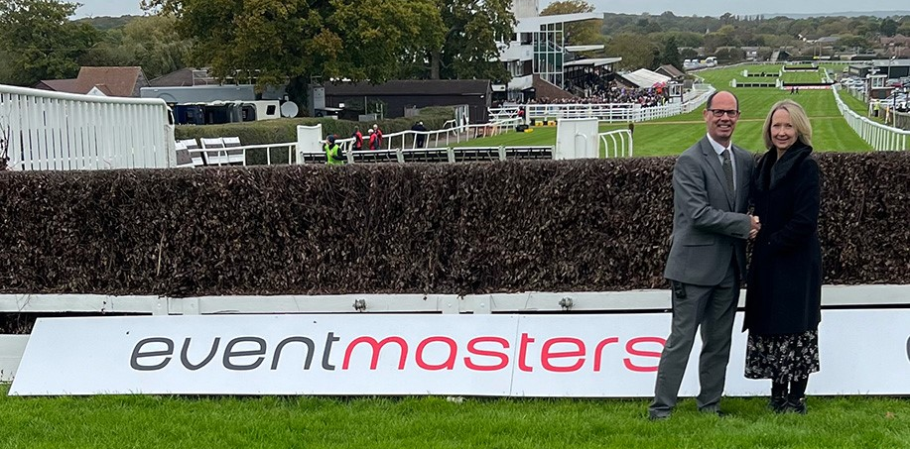
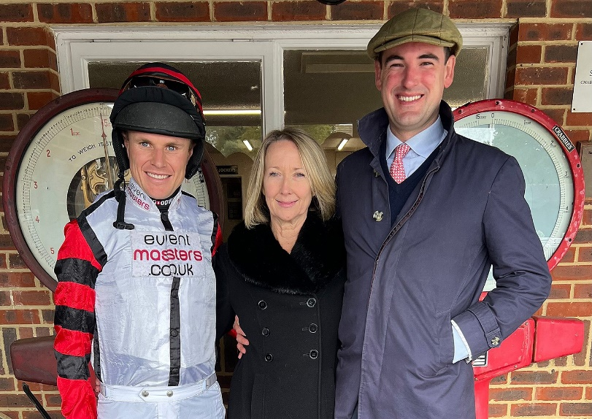
Denise Sheasby CEO of the Eventmasters Group said, "We have enjoyed working with Craig Staddon at both Cheltenham and Ascot Racecourse, so when he presented the opportunity to us, as part of his new role as Chief Executive at Plumpton, we were delighted to get involved.
Plumpton is a lovely racecourse with a great atmosphere, it attracts good crowds, it is less than an hour by train from London Victoria and has full coverage on Sky Sports Racing. It is a perfect fit for the Eventmasters brand"
Eventmasters are already involved with racing in the local area and have 2 horses in training with two local trainers. Den the Diva in training with Andy Irvine and Silent Auction with Toby Lawes. Both Jockeys that are welcomed to Plumpton Racecourse regularly.
Craig Staddon said "We are really pleased that Eventmasters are on board at Plumpton. They are industry leaders in the provision of hospitality at both Flat and National Hunt Racing Festivals and the fact that they support the sport through sponsorship and via their own successful racehorse ownership activity is a credit to them. Plumpton will provide the brand with great exposure. We look forward to welcoming them and their guests through the year and fingers crossed that one of their charges can deliver a success here at Plumpton this season”.

Eventmasters x Plumpton Competition
Eventmasters and Plumpton have teamed up to offer a competition to be an owner for the day at the next race meeting at the course on Monday 6th November 2023. Eventmasters Racing plan to run the locally trained Den the Diva in the opening Mares Novice Hurdle and you can be part of the team for the day. The prize for 2 guests will include. O&T badges, lunch, joining connections within the Parade Ring prior to the race and who knows, maybe the Winners Enclosure post race! There will also be 6 runners up prizes of a pair of general admission tickets into the Grandstand & Paddock Enclosure for the day.
To enter please like or follow Eventmasters on one or more of their social media platforms
And answer the following question ...
Who was the leading jockey at Plumpton Racecourse last season?
Please send your answer to VIPHospitality@eventmasters.co.uk and also confirm the social media platform(s) on which you have connected. The winner and runners up will be drawn, announced and notified on Thursday 2nd November 2023. Good Luck!

